STATEMENT OF WORK

**Objectives:**  
The main objective of the project is as the developed application is in VB6 and to make it more scalable and reliable we are converting the EIMS applications into ASP.NET MVC4 as per the latest technologies.

**Scope of work:**

The **Employee Information Management System (EIMS**) is developed to Computerize the administrative work of Establishment Division for Category-B , Category-C and Category-D employees. This system will help in carrying out all administrative work of the Establishment Section and help in generating reports for analyzing and future planning.

* **Software requirements:**

Software Developed in Microsoft Visual Studio2012

Data base: MS SQL SERVER 2008

Report Generation: SEAGATE CRYSTAL REPORT 8.0

All Web related functions are developed using ASP.NET MVC4 Technology.

* **Hardware** : Minimum configuration required are

Application Server - Windows 2000 Server

Processor - Pentium III or above

RAM - 256 MB

HD Capacity - 80 GB and above

Network card speed - 100 MBPS or above

Client System - Windows 2000 Professional

Processor - Pentium I or Above

RAM - 128 MB or above

HD Capacity - 20 GB or above

Network Card Speed - 100 MBPS or above

Micro Soft Networking - LAN with NET BEUI Protocol.

**Period of perfomance:**

* **Schedule**

**EIMS1A:**

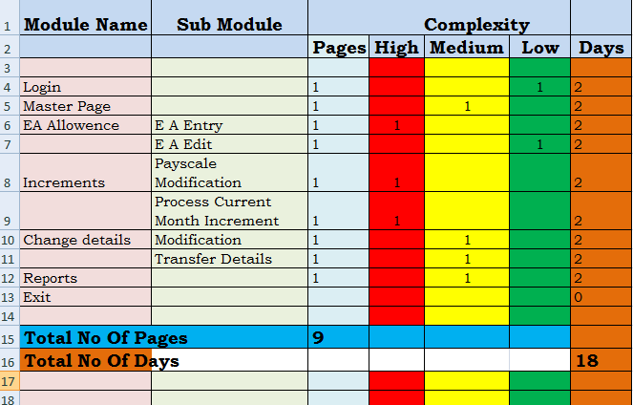

**EIMS1A,1B and QMS Sprints:**

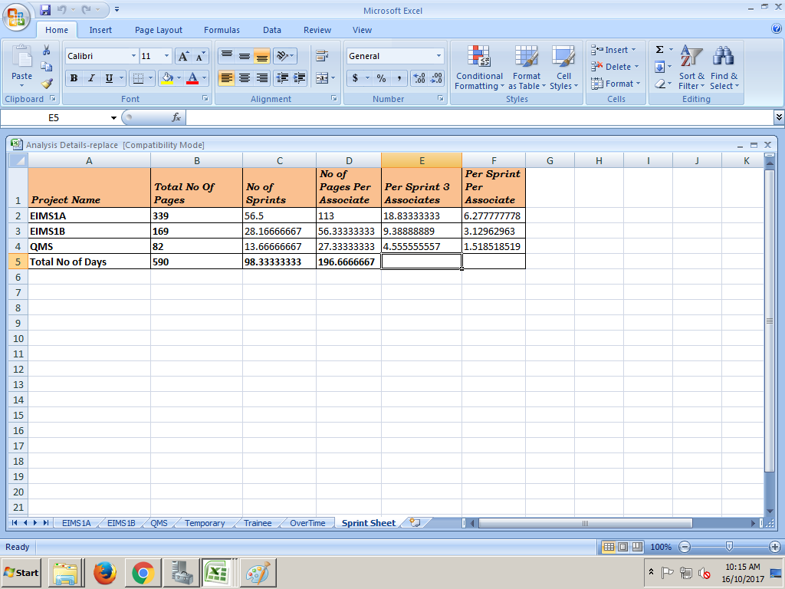

**Contract Terms and payment Schedule**: